Documentation
Travel app

University: Astana IT University
Instructor: Nurgul Assanova
Group: SE-2010
Members: Merey Orynbassar, Nurlan Abzalbekov, Kamila Kiyubaeva

Travel app
Members: Merey Orynbassar, Nurlan Abzalbekov, Kamila Kiyubaeva

Introduction:
Our team project is a Tourist helper app. This app will help to visit popular areas of our country as well as the hidden gems that generally do not get the attention they deserve. The advantage of this project to develop the tourism of Kazakhstan.This project will be developed for Kazakhstan. We decided to make our app first for our main two cities such as Nur-Sultan and Almaty.We will show the beautiful places and the nature of our country.

Analysis:
We analyzed our market in Kazakhstan and we found only one app. This is TripAdvisor. This app has a lot of features and is supported as a website, IOS app and android app,but it’s intended for worldwide use and we didn’t find the analogue of this app in Kazakhstan. Additionally, we found some disadvantages of this app.For instance, we searched the places in Nur-Sultan and we found that the data in the app is not updated. They could add new places but they couldn’t do that.So, we decided to make the analog of TripAdvisor but with modern design and related to our country. We hope that it will be the cutaway of our country.

Users:
Firstly, our users will be the travelers who came to our country abroad. We analysed our tourism and we found that most of the tourists first visit the cities such as Nur-Sultan, Almaty. So, it can be as a mobile handbook but with more features.There will be the categories. We found it interesting and by this feature the user can visit the places that she/he wants

Design: Figma
Languages: React Native,Api
Front-end:React Native, React Navigation, React Redux
Back-end: React Native ,Google Api, PostgreSQL

Our prototype: TripAdvisor.
Our users: Travellers
Language: English

Responsibilities of each member:
Nurlan:Back-end:React Native , Google API, PostgreSQL
Merey: Front-end:React Native, React Navigation
Kamila:Front-end:Figma, React Native, React Navigation

Travel cities: Nur-Sultan, Almaty

user:
1)sign up:
name
password
repeat password

2)login:
email
password

Home page:
*places

menu:
Home
Favorite(in Home Screen)
Profile
Map
Navigation

Places:
*Pictures
*Name
*Address
*Description
*Map
*Rating

Profile:
*photo
*name
*email
Our supposed interface
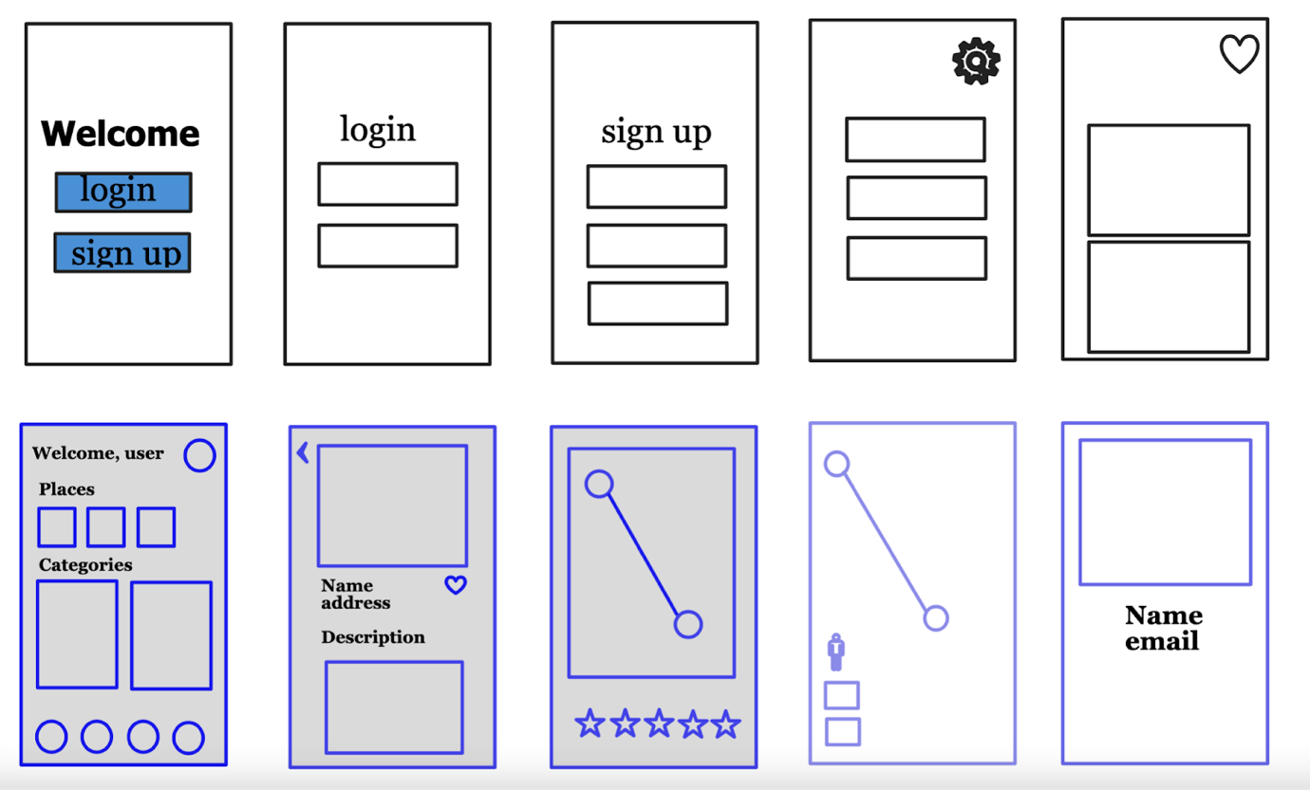

Design
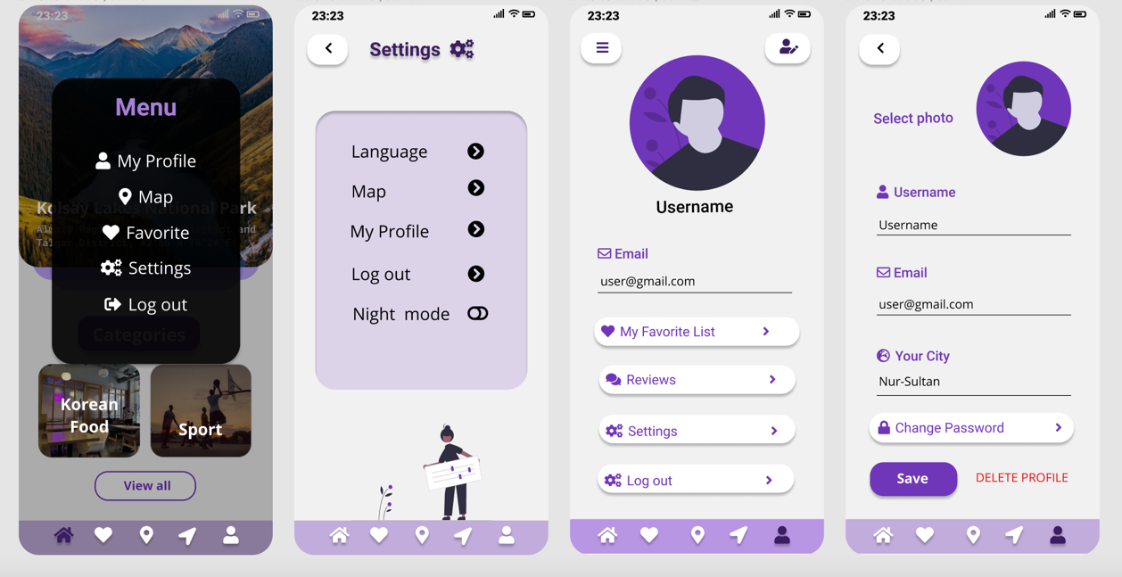

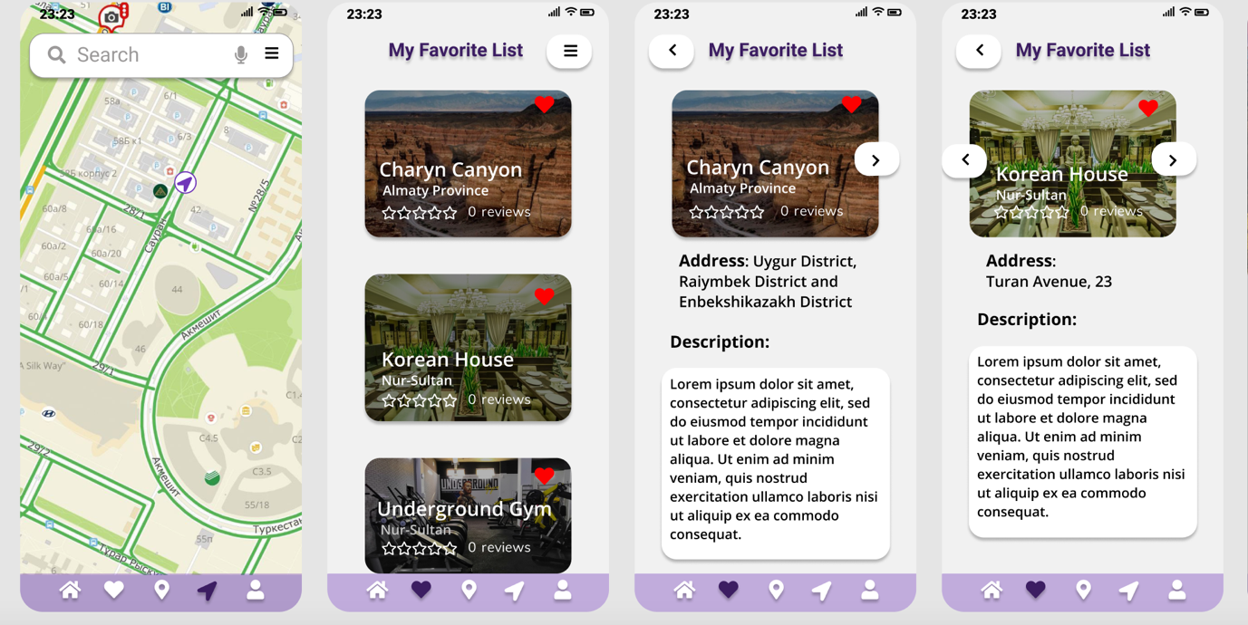

Our Project Plan
Tasks | Members | Priority | Status
Week 5
Finish the design | Kamila | High | In process
Collect the information about travel places (photo, description, categories) | Merey | High | In process
Connect the node.js with express and start working with user login and sign-up functions. | Nurlan | High | In process
Week 6
Start working with the front-end. | Kamila | High | Not ready
Add rating function | Merey | High | Not ready
Finish the login and sign-up pages and connect the data with Postgres and test it. | Nurlan | High | Not ready
Week 7
Finish main page and page with places. | Kamila | High | Not ready
Add the data to the front-end. For example, the photo and name. | Merey | High | Not ready
Work with Map API | Nurlan | High | Not ready
Week 8
Finish welcome page and map page. | Kamila | High | Not ready
Work with favorite button and how to add to the list the places | Merey | High | Not ready
Add some features to Map API and finalize it. | Nurlan | High | Not ready
Week 9
Finish the front-end | Kamila | High | Not ready
Finish the favorite page functions | Merey | High | Not ready
Configure cache operations in program | Nurlan | High | Not ready
Week 10
Fix the problems and add the languages. | Kamila | Medium | Not ready
Overall test the program and if it’s needed add some cool functions. | Merey | High | Not ready
Test the program for requests and for API | Nurlan | Medium | Not ready

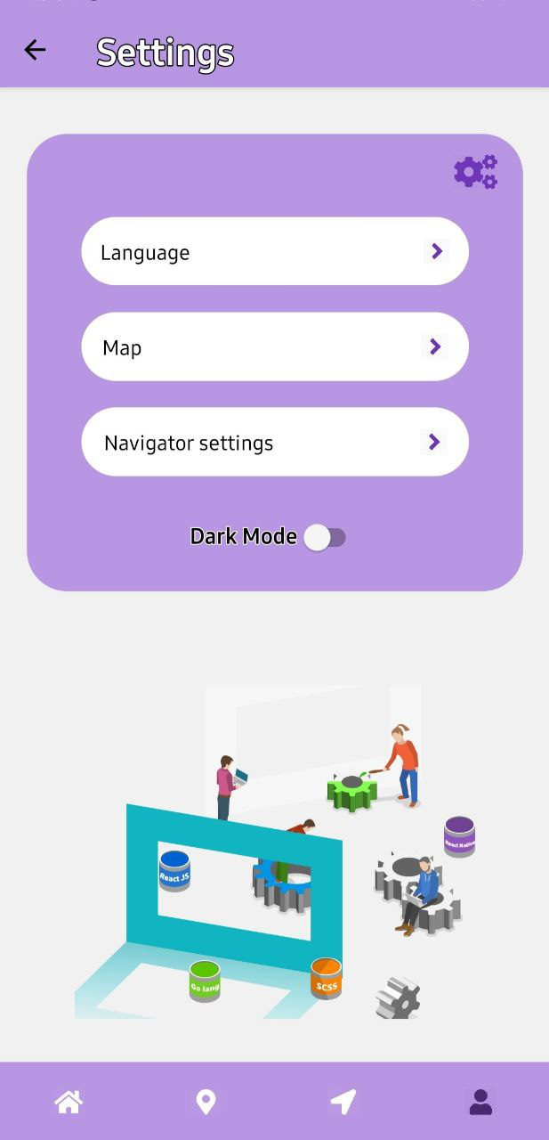
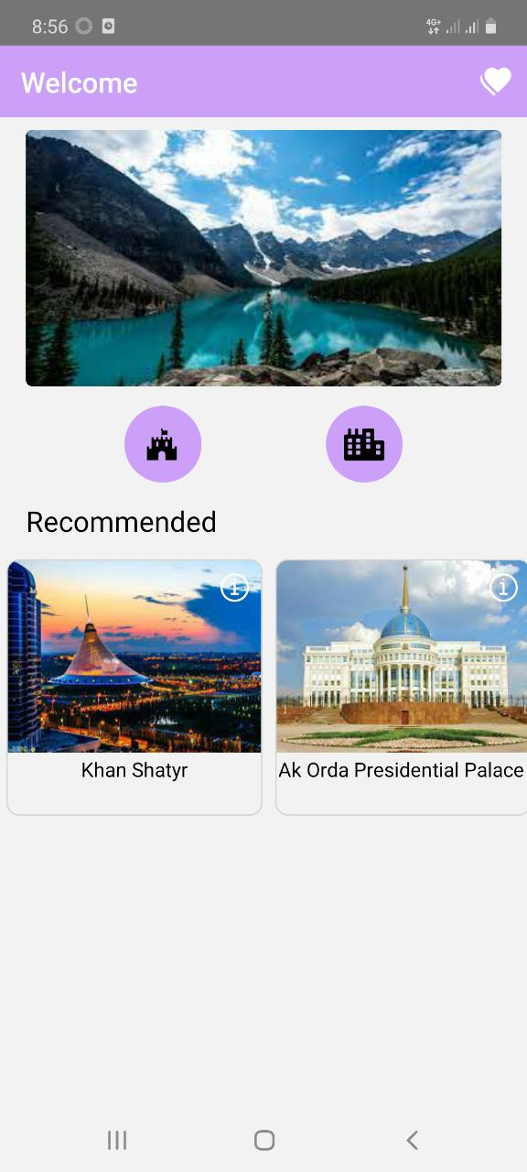
Our App
